Computer programming

Final Project

Report

I.E.S. San Vicente
San Vicente del Raspeig (Alicante)
2017/2018

Teachers:
José Ignacio Cabanes / Ignacio Iborra

Student:
Raul Gogna

1. Introduction
Project name
Diary in console

Made by
Raul Gogna

Short description of the project
It is a graphical diary in console, where you can look, modify and add tasks,
contacts, tasks to do, and share events via email.

2. Functionality of the project
After starting the program, a menu will be displayed, where the user can choose between:

- See calendar.
- See contacts.
- See tasks to do.
- See notes.
- Close the program.

If the user chooses to see the calendar, the current month will be displayed on a new screen, the display of the calendar can be changed in: day, week or month, and depending on the display, it will be displayed in one way or another. If the user chooses the display by day, the day with the hours will be displayed and if there are tasks, they will be displayed; if the user chooses the display per week, the current month will be shown week by week, and the user can use the arrow keys to enter a day and show that day, where he can modify the tasks of that day or add tasks; if the user chooses the display by month, they will be shown every day of the month, and the days that have tasks or events, will be highlighted in one color.

If the user chooses to see contacts, they will be shown on a new screen, the contacts with their information, and each contact will be able to edit, and send by email, and through the arrows on the keyboard it will be possible to change contact.

If the user chooses to see tasks to do, all the pending tasks will be shown without a deadline, it will also be possible to indicate if this task has been completed, in which case it will be deleted from that list.

If the user chooses to see notes, the notes will be displayed in a new screen, the notes saved, and they can be modified, added or deleted.

If the user chooses to close the program, all the changes made will be updated, and when the program is started again, all the data in a file will be loaded.

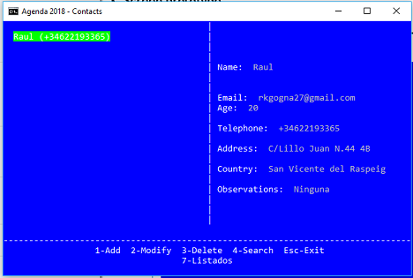
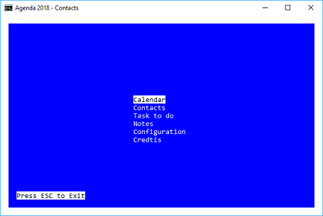
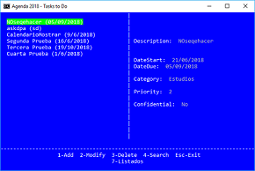
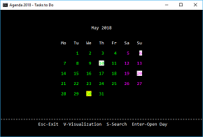

3. Screen prototype
The game screen will look like this:

4.Analysis

4a. Requisites
Requisite | Date achieved
The program will allow you to show the current calendar and visualize pending tasks in it, as well as to add a task on a specific day.
The program will allow you to move through the calendar using the direction arrows, you can also change the type of calendar display, using an option.
The program will allow importing another person's calendar and showing it in the program.
The program will allow you to show the saved contacts, and add new contacts to the agenda, modify them, sort them by alphabetical order or another sort, delete, send a specific contact or the whole contact agenda by mail, through the send option.
The program will show a welcome screen and a credit screen. | x
The program will allow you to enter the pending tasks screen and show the list of tasks, and show those tasks in the calendar in their respective days (if the user allows it); modify the tasks or delete them, change the ordering of the list of tasks by current date, priority, old or recent.
The program will allow you to enter the notes screen, where you will see the added notes, you can modify the notes, delete, add new note. | x
The program will allow you to exit the program using the Esc key. | x
The program will allow you to change the background color of the screen, such as the letters, by means of the configuration screen in the main menu. | x
The program will save all modified data when leaving the program.  The program will load all the data of the agenda at the beginning of the program. | x

4b. Basic pseudocode

Program body:
Display welcome screen
Wait for user to press a key
If key = ESC, quit program
If key = 1, start one player game
…

One player game:
Display level selection screen
Wait for user to press a key
If key = ESC, return
…

…

4c. Classes diagram
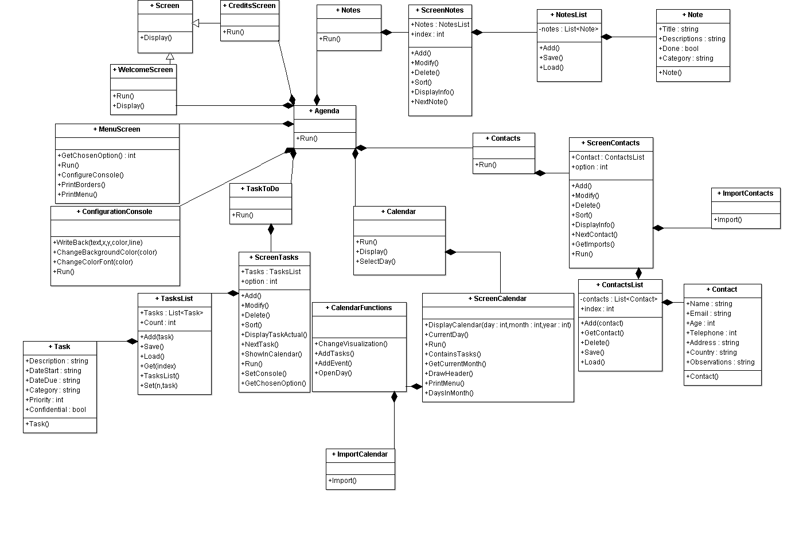

5. Initial planning and expected deliveries

5a. Expected deliveries
- Version 1: Create the basic structure of the program, with its classes (empty at this moment) and create the main menu where you can access the previously commented options by means of the arrows.
- Version 2: Implement class of welcome screen with animation on screen.
- Version 3: Create enhanced console configuration class: change the background color, font color, this at the user's choice; Functions to save project code such as: request (save code on data entered by user) and write (save code on displaying data in the console, as well as showing with one color or another and coordinates on the screen).
- Version 4: Implement calendar class with its initial functionalities(show current month).
- Version 5: Modify the calendar display in week, day or month for console, according to the user's choice; the design of the visualization will be done manually in code by the student.
- Version 6: Implement class of pending tasks with their attributes and methods, and display on screen.
- Version 7: Implement class of contacts where you can show the saved contacts or add them, modify them, find a contact, etc.
- Version 8: Allow adding tasks to the calendar in the CalendarFunctions class, accessing the day with arrows.
- Version 9: Implement class of notes(Notes, Note, NotesList) with their methods, properties.
- Version 10: Implement class of ScreenNotes, with all methosds: Run(), Add(), Modify(), Delete(), Sort(), ChosenOption(), DisplayNotes(), ConfigScreen()
- Version 11: Implement class to be able to import contacts from other users and add them to our contact list.
- Version 12: Create functionality to be able to mail tasks or events or contacts by email.
- Version 13: Implement functionality to show pending tasks in the calendar in ScreenCalendar class.
- Version 14: Create credit screen class with animation.
- Version 15: Implement importCalendar class to be able to import calendar from other users and visualize that calendar with its tasks and events on the calendar page.

5b. Real deliveries
- Version 1 (May 14): As expected. Created the skeleton of the program with its classes (empty for the time being) and the main menu class completed.
- Version 2 (May 15): As expected. The welcome screen has been created with its animation of a progressive bar.
- Version 3 (May 16): As expected. The ConfigurationConsole has been created with its functions.
- Version 4 (May 17): (Brandon Blasco) As expected. I have created the calendar class in which the current month and year is shown, I have not shown the days in calendar format.
- Version 6 (May 18): As expected. I implemented classes Task, TasksList and ScreenTasks, then its called in class MenuScreen. Still missing.
- Version 6.2 (May 21): As expected. I finished all methods of class ScreenTasks.
- Version 7 (May 22): As expected. I implemented all classes abouts Contacts, except ImportContact class. I improve ScreenTasks.
- Version 9 (May 23): As expected. I implemented classes Note, NotesList, and added class GlobalListNotes, with their methods, and I improve screen Calendar and added ScreenCalendar with their methods.
- Version 10 (May 24): As expected. I implemented ScreenNotes class with most of the functions.
- Version 14 (May 25): As expecetd. I implemented CreditsScreen.
- Version 13 (May 28): As expected. I implemented function to show tasks in the calendar screen.
- Version 8 (May 29): As expected. I implemented function to move around the calendar with arrows. Screen is father class, and WelcomeScreen and CreditsScreen are son.
- Version 8.2 (May 30): As expected. I improve version 8 and functionality is good.

6. File formats

6a. Plain files format
I will use files to save and load the contacts of the ContactsList class in this way:

Contacts:
Name:
Email:
Age:
Telephone:
Address:
Country:
Observations:

6b. Entity-Relationship Diagram (If needed)
(…)

7. Problems found and solutions
I delete classes Event, Events and EventsList, because I have miscalculated the time to implement these classes. And the function to move around the calendar with the arrow keys has been removed from the FunctionsCalendar class and that function has been implemented throughout the ScreenCalendar class.

(…)

8. Improvements or restrictions to the starting design
I have had time enough to include the effect of animation when the pieces fall (…)

I have not been able to implement (…) because of (…)

9. Screenshots of the final project
(…)

10. Source code of the final project
(…)

